**Cognizant Deep Skilling Mandatory Hands-On Questions**

**TOPIC- Spring REST using Spring Boot 3 Exercises**

**Exercise 1:** Create a Spring Web Project using Maven

Ans)

Step1) Go to <https://start.spring.io>

| **Field** | **Value** |
| --- | --- |
| Project | Maven |
| Language | Java |
| Spring Boot | Default |
| Group | com.cognizant |
| Artifact | spring-learn |
| Name | spring-learn |
| Packaging | Jar |
| Java | 17 (or your installed version) |

* **Add Dependencies :** Spring Web & Spring Boot DevTools

And generate it

Step2) Download the zip file, extract it and open it in your Java Compiler (IntelliJ in my case)

Step3) Run 'SpringLearnApplication.main()

**OUTPUT**

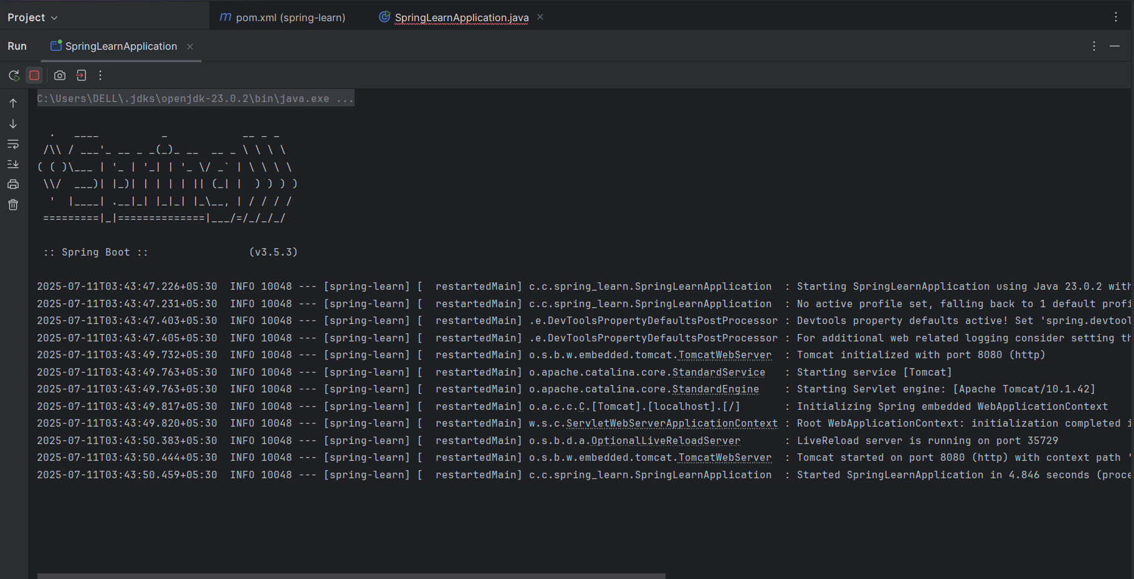

**Exercise 2:** Spring Core – Load Country from Spring Configuration XML

Ans)

Step1) Go to <https://start.spring.io>

Fill in:

* **Group**: com.cognizant
* **Artifact**: spring-learn
* **Add Dependencies :** Spring Web & Spring Boot DevTools

And generate it

Step2) Download the zip file, extract it and open it in your Java Compiler (IntelliJ in my case)

Step3) Create Country.java Bean

In ‘src/main/java/com/cognizant/springlearn/’

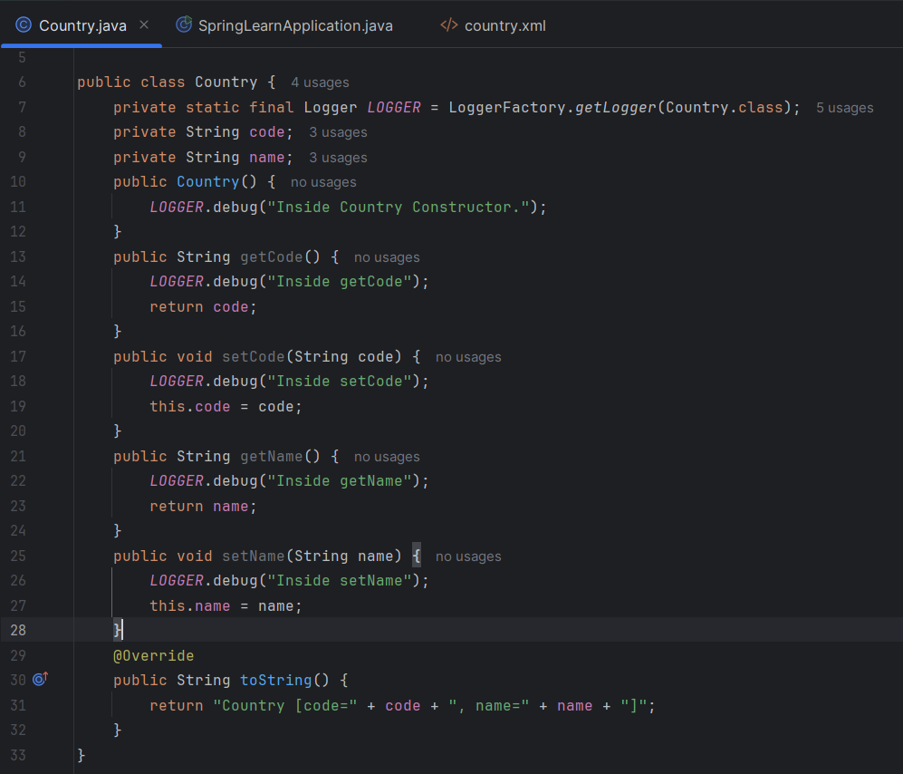

Step4) Create country.xml Configuration

In ‘src/main/resources/’

And write the following content

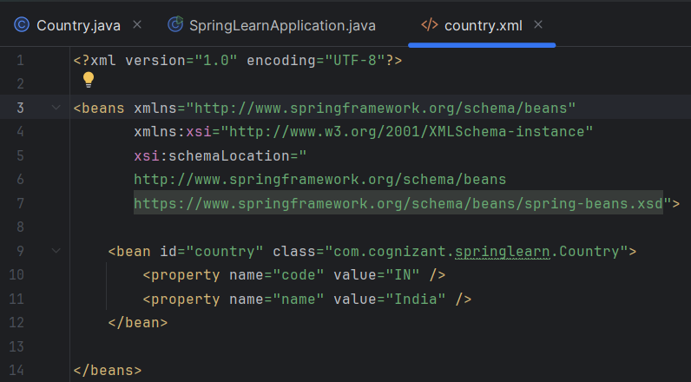

Step5) Modify SpringLearnApplication.java and run it

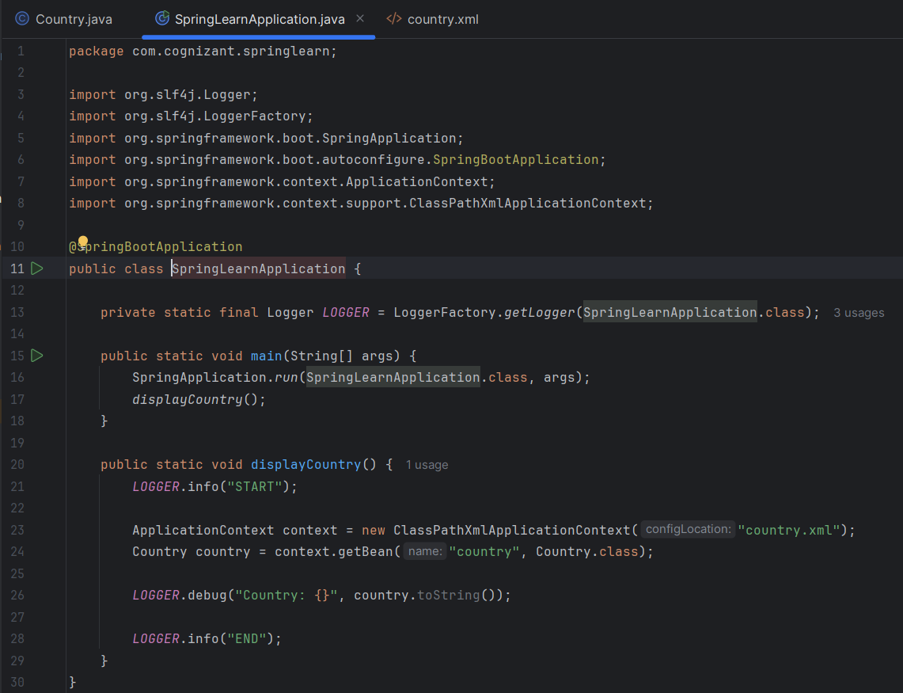

**OUTPUT**

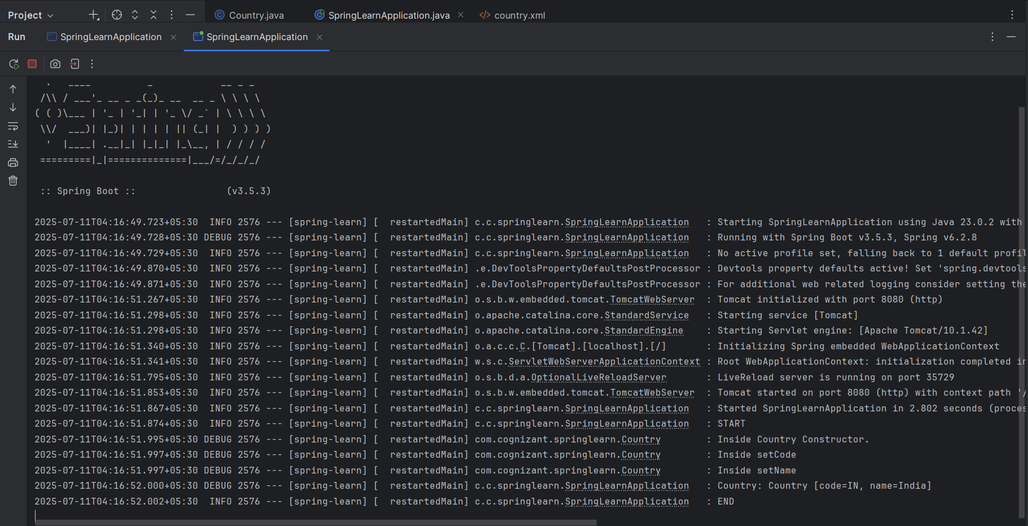

**Exercise 3:** Hello World RESTful Web Service

Ans)

Step1) Create a new maven project

Step2) Give the suitable GroupId and ArtifactId (given in the question)

Step3) Update the pom.xml file

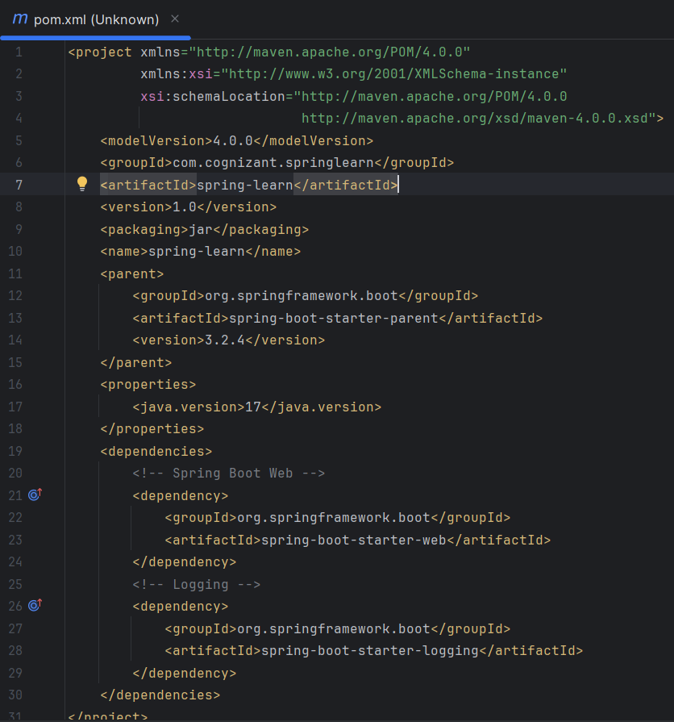

Step4) Create ‘com.cognizant.springlearn.controller’ package inside ‘com.cognizant.springlearn’

Step5) Create the Main Application Class

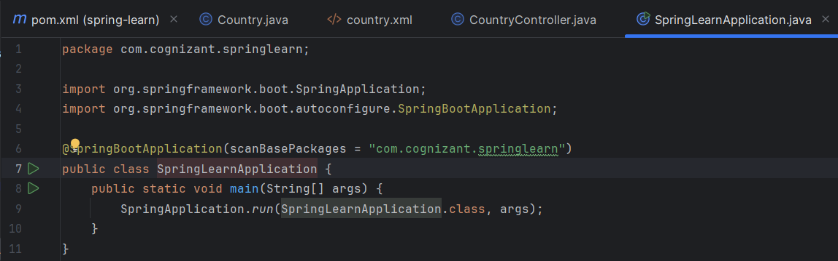

Step6) Create Hello Counter

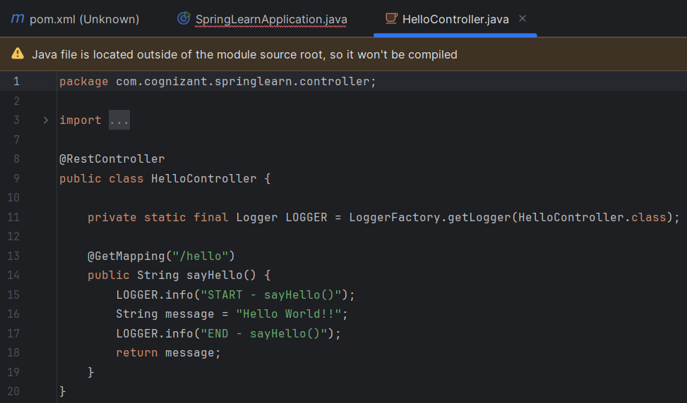

Step7) Set server port to server.port=8083

Step8) Run ‘SpringLearnApplication.java’

**OUTPUT**

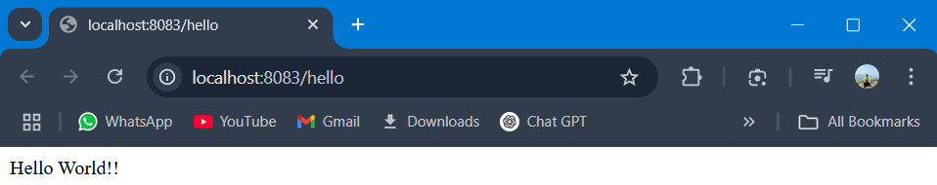 Browser

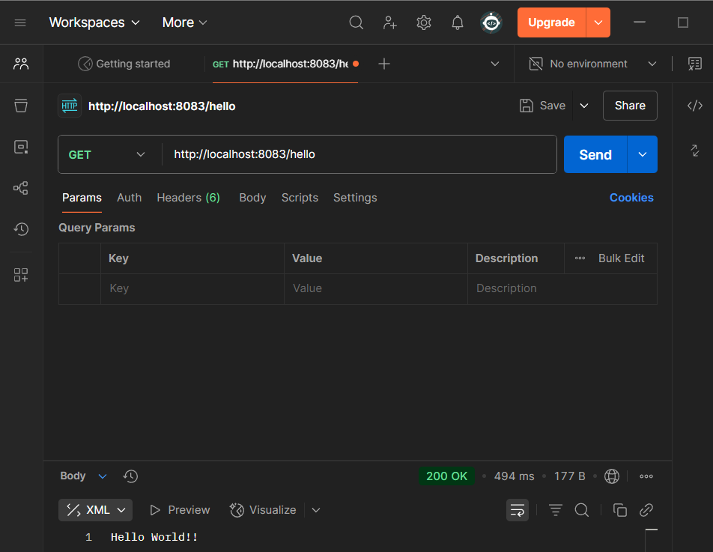Postman

**Exercise 4:** REST - Country Web Service

Ans)

Step1) Update the pom.xml from previous exercise 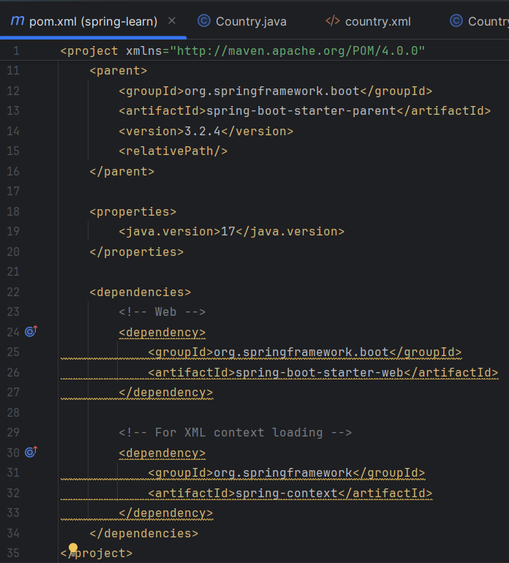Step2) Create Country Java Bean

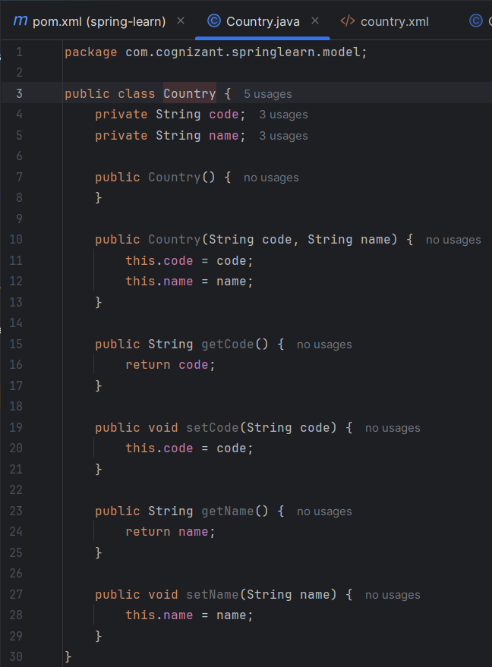

Step3) Create country.xml in resources

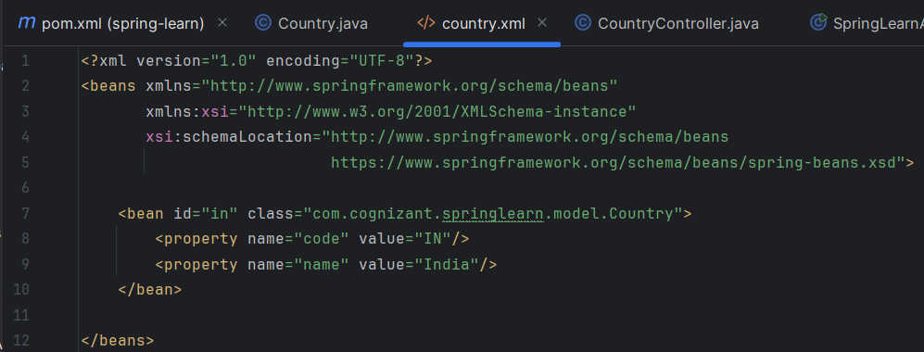

Step4) Create CountryController class in ‘src/main/java/com/cognizant/springlearn/controller/’

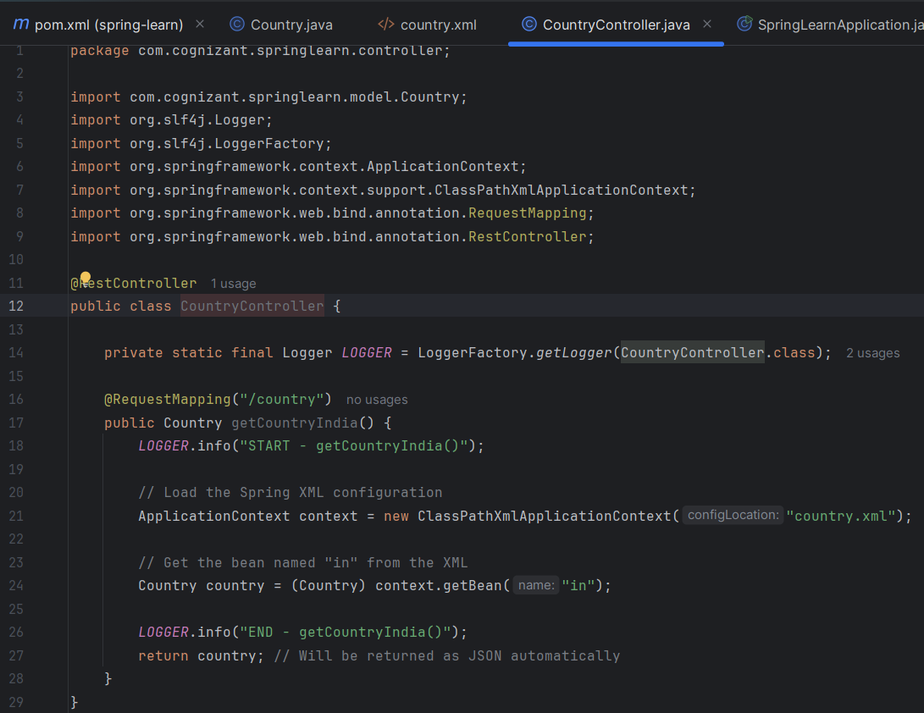

Step5) Create Main Class and set the server to ‘server.port=8083’

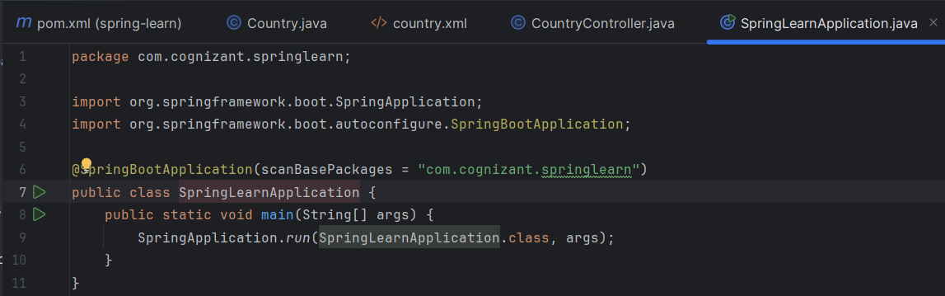

Step6) Run ‘SpringLearnApplication.java’

**OUTPUT**

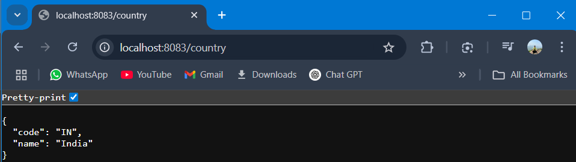

**Exercise 5:** REST - Get country based on country code

Ans)

Step1) Update the country.xml file from previous exercise 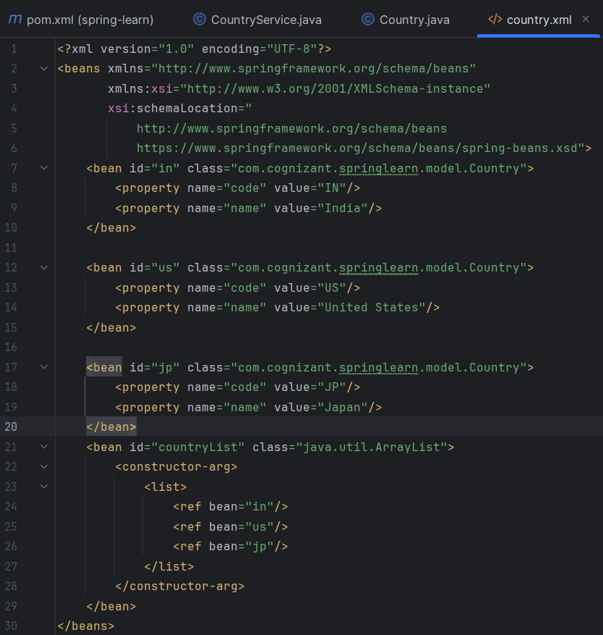

Step2) Create a CountryService class

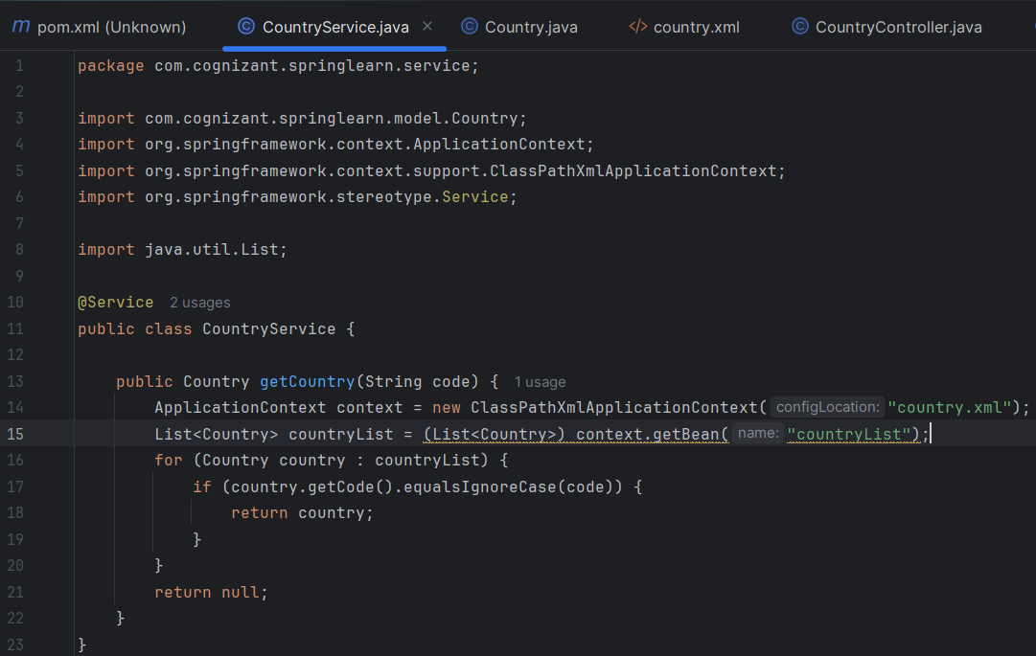

Step3) Update CountryController to Add New API

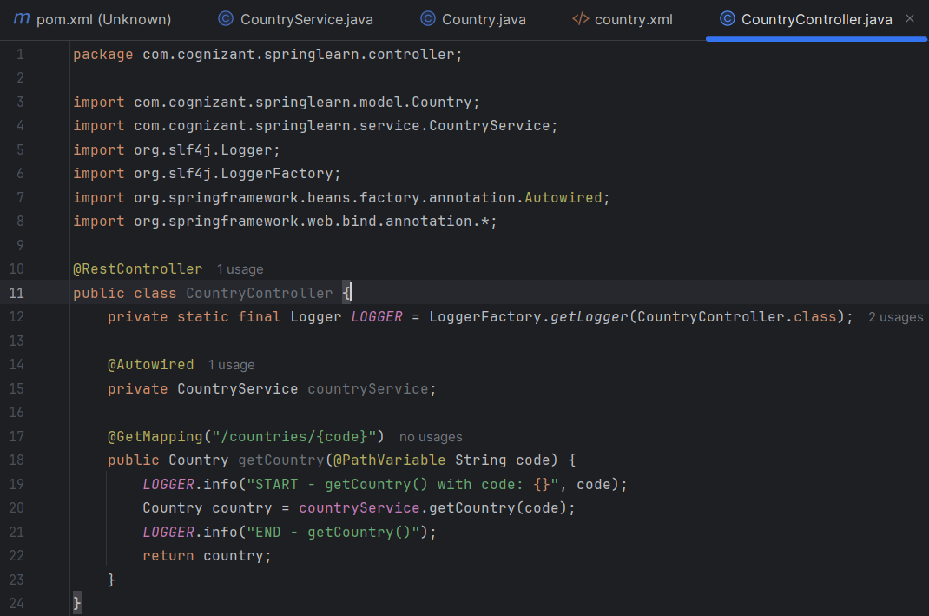

Step4) Run ‘SpringLearnApplication.java’

**OUTPUT**

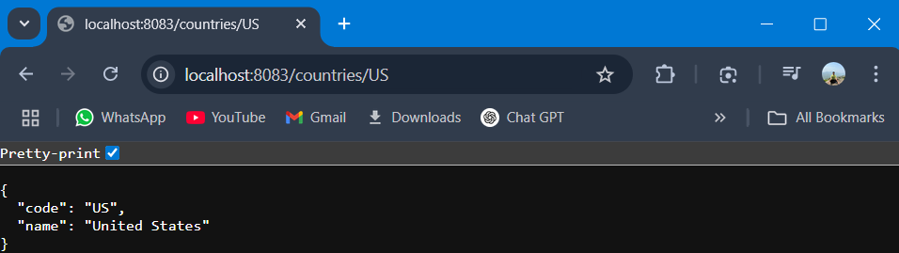

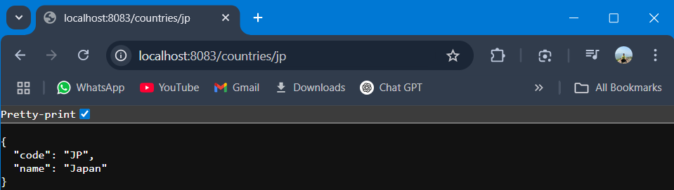

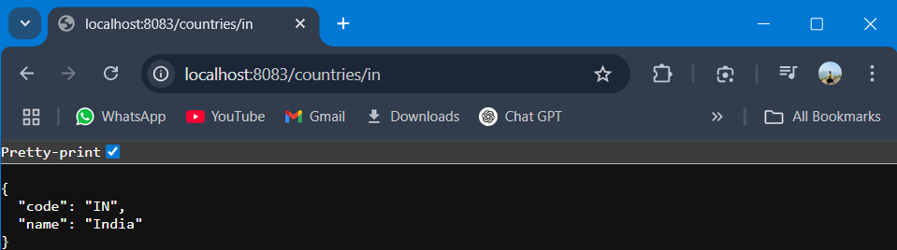

**Cognizant Deep Skilling Mandatory Hands-On Questions**

**TOPIC- JWT Exercises**

**Exercise 1:** Create authentication service that returns JWT

Ans)

Step1) Update the pom.xml file from the previous exercise

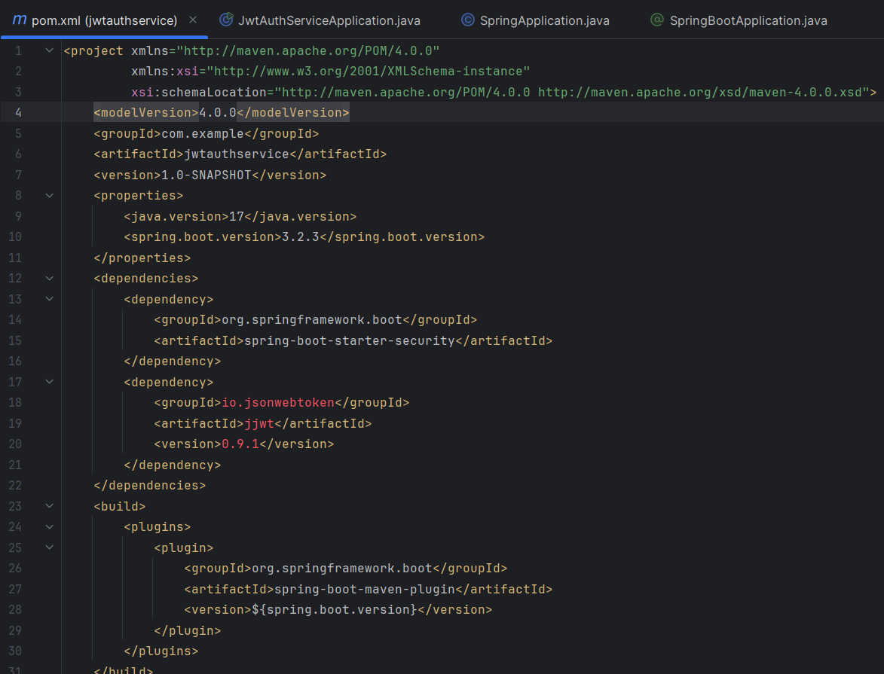

Step2) Create SecurityConfig class

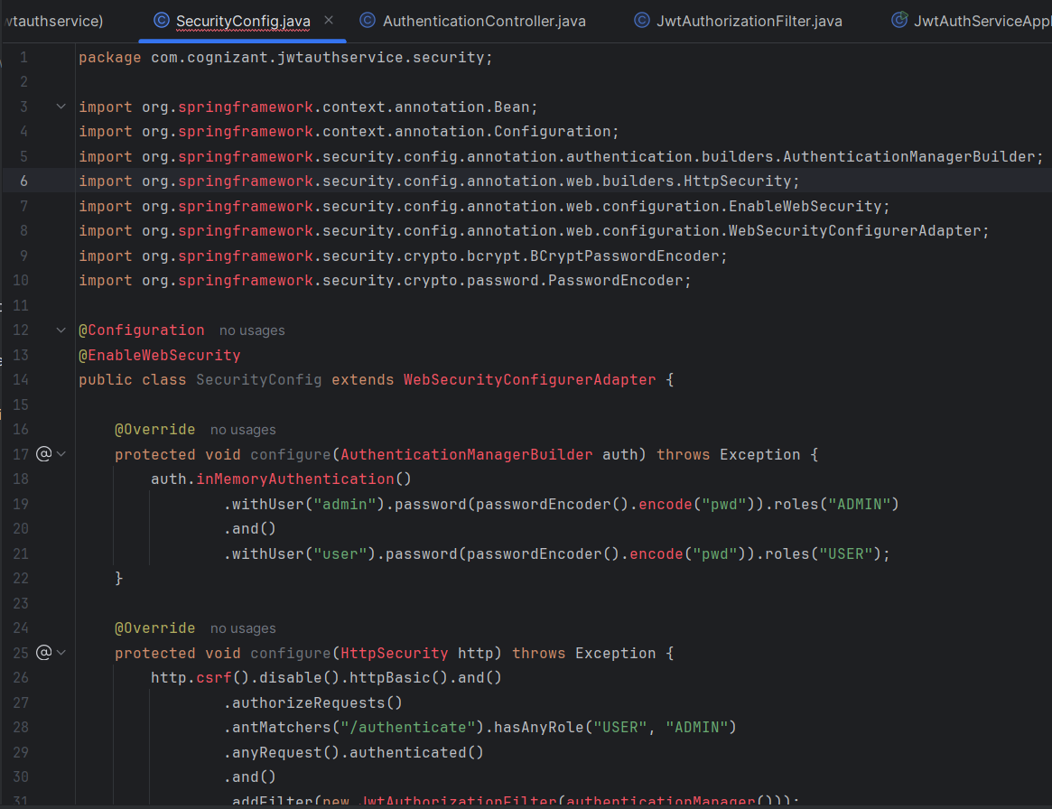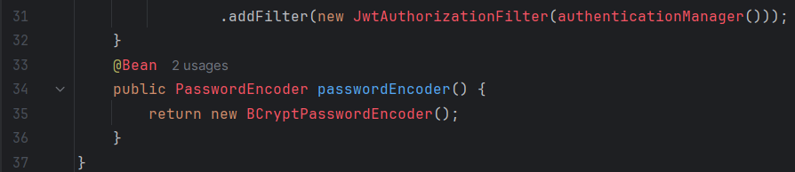

Step3) Create Authentication Controller

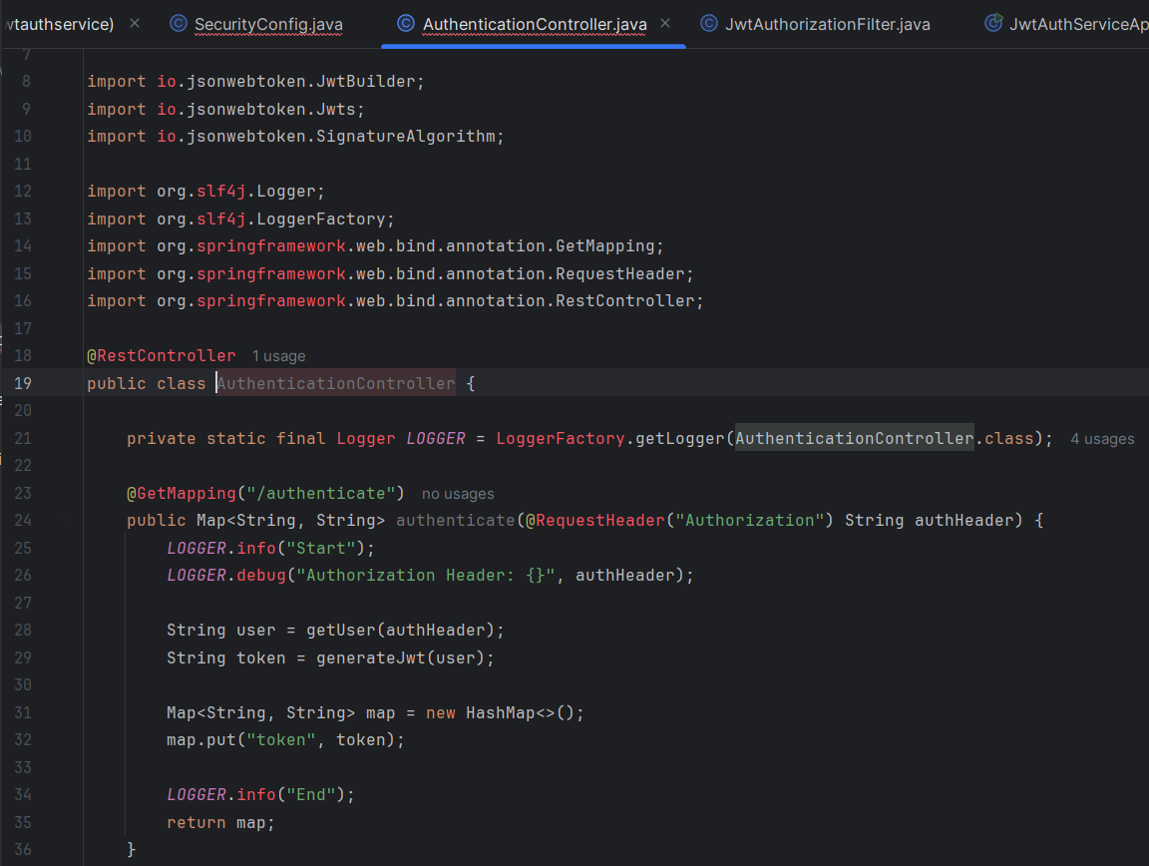

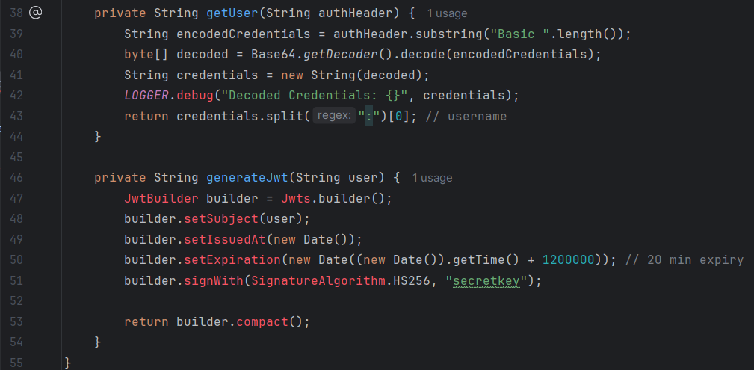

Step4) Create JWT Filter

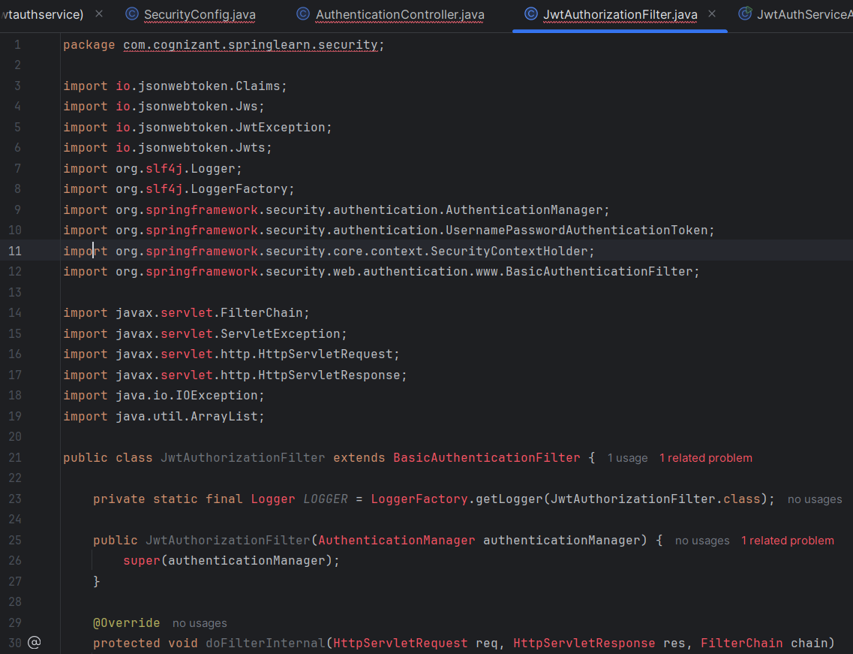

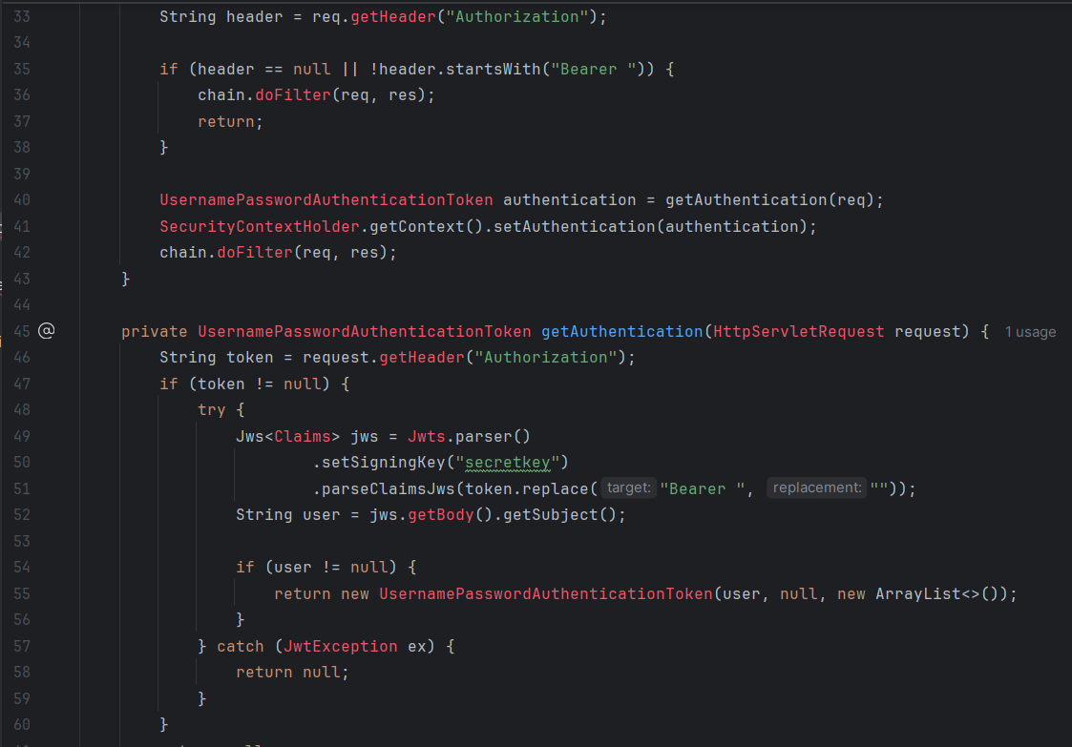

**OUTPUT**

